2017-01-25

Bryan Greener

Chad Hirsch

Jason Gunderson

Chapter 2.1



2.18

a) Looking at the graph, the amount of Carbohydrates in the beers seems to be very loosely correlated with the Alcohol Percentage. The form is clustered. Strength of correlation is weak. There are a couple outliers as well.

Using the cor() function confirms this. Cor(PercentAlcohol,Carbohydrates)=0.287

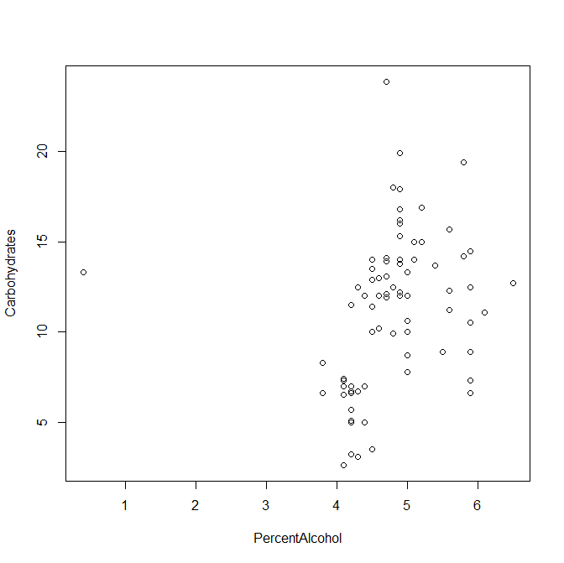

2.43

a) cor(PercentAlcohol,Carbohydrates) returns 0.2872885

2.44

a) cor(PercentAlcohol,Carbohydrates) returns 0.4184595



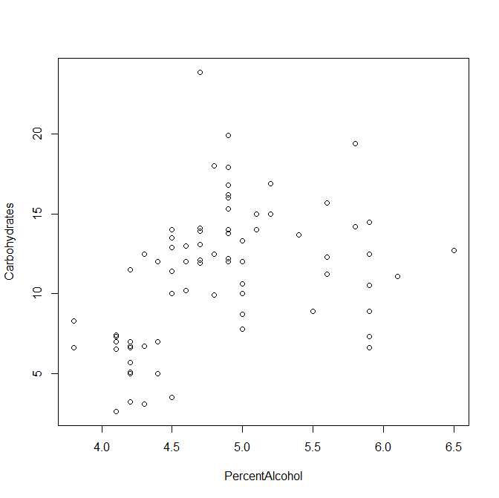

b) Any outliers in a dataset will cause the correlation to be weaker due to extra values that do not fit the rest of the dataset’s form.



Code Attached Below

beerlist=read.csv("beer.csv")

attach(beerlist)

dim(beerlist)

plot(PercentAlcohol,Carbohydrates)

cor(PercentAlcohol,Carbohydrates)

which(PercentAlcohol==min(PercentAlcohol))

PercentAlcohol[57]

beerlistOutlier=beerlist[-57,]

detach(beerlist)

attach(beerlistOutlier)

dim(beerlistOutlier)

plot(PercentAlcohol,Carbohydrates)

cor(PercentAlcohol,Carbohydrates)

detach(beerlistOutlier)